Genius sis

API

Document number: 2016041901
Version: 3.0
Release Date: 07/15/2016

Overview
This document describes the API calls available to support the integration needs of <Client>.

The API consists of SOAP-based webservices, and can be located at

https://<client>.geniussis.com/PublicAPI.asmx

The WSDL can be found on

https://<client>.geniussis.com/PublicAPI.asmx?wsdl

All methods require a token, which is set to

<TOKEN>

To access the Genius UI, you can use the following information:

url: https://<client>.geniussis.com
username: <username>
password: <password>
Available Webservices

SaveAffiliation
This webservice will allow you to create a new affiliation or update an existing one. If the provided AffiliationID is found in the database, that affiliation will be updated, otherwise a new affiliation will be created.

The field “BlackboardRole” specifies the learner roles used whenever a learner is created in Learn.

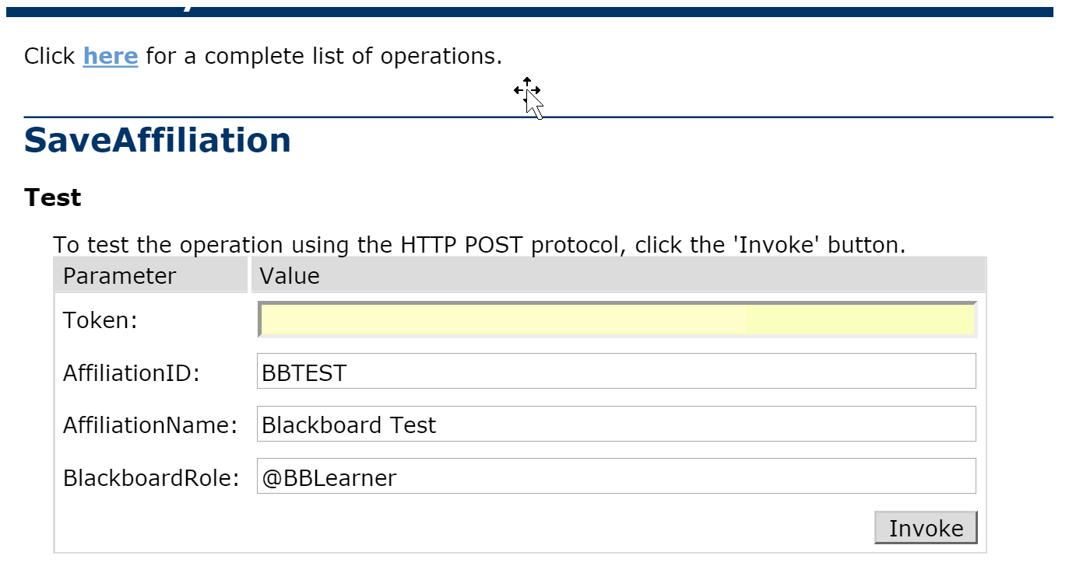

The webservice will return a message confirming the affiliation was created, or an error message.

GetAffiliations
This webservice will return a list of all existing affiliations in the database.

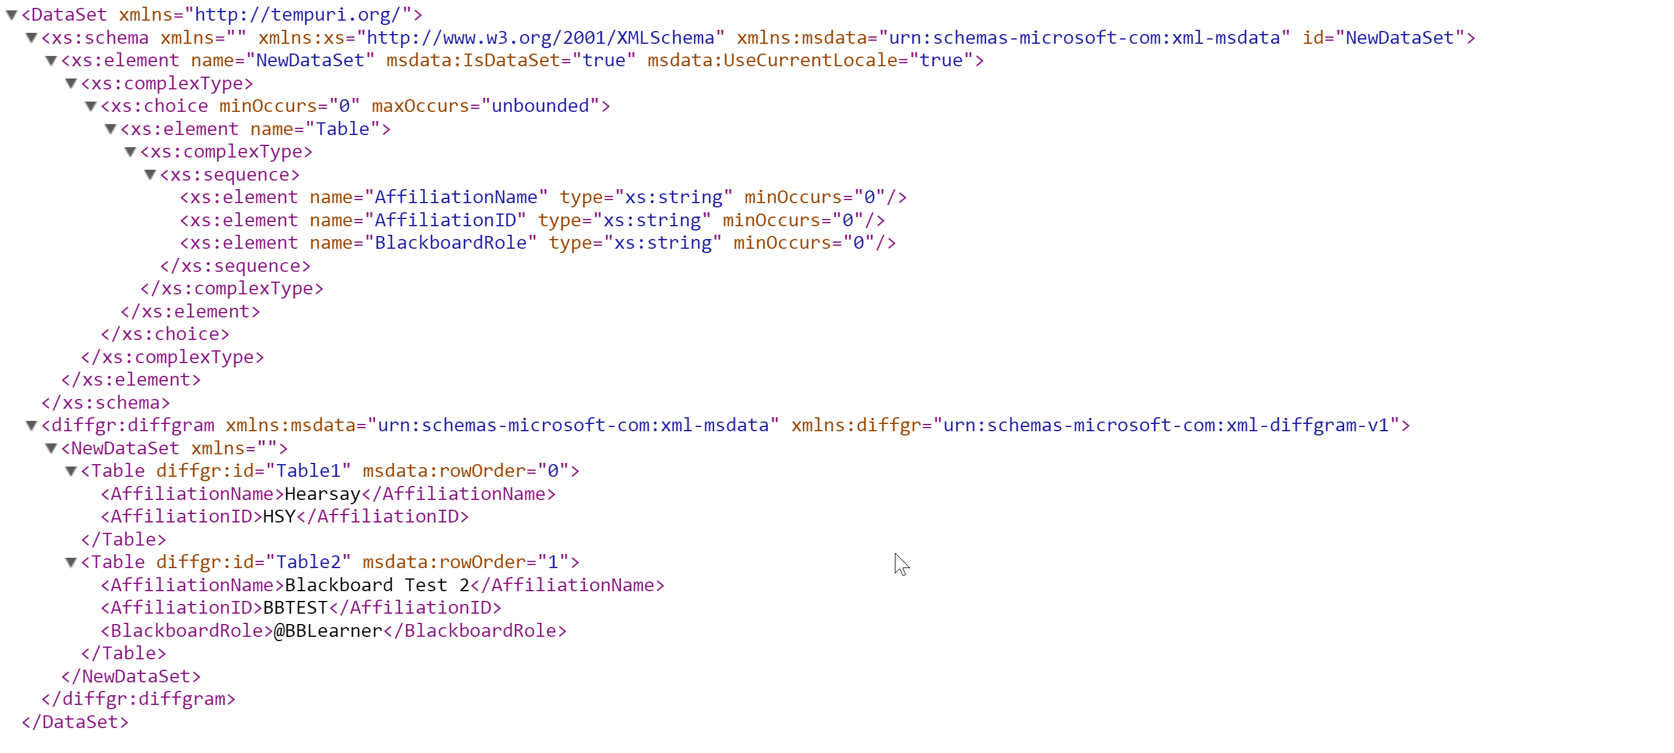

SaveUser
This webservice will allow you to create a new user or update an existing one. If the provided username is found in the database, that user will be updated, otherwise a new user will be created. The parameter LearningPathName is only applicable when the role is LEARNER.

The field “Role” must point to a pre-configured Role (Admin, Coach, Learner, Instructor or Manager) or a custom role.

You cannot update the role of an existing user.

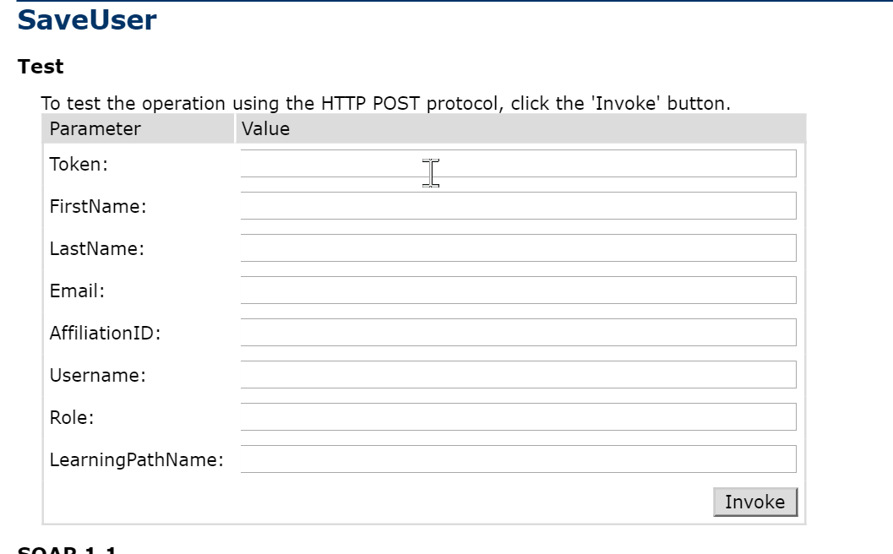

The webservice will return a message confirming the user was created/updated, or an error message.

GetUsers
This webservice will return a list of all existing users. If an affiliation is specified, only users associated with that affiliation will be returned. If a role is specified, only users with that role will be returned.
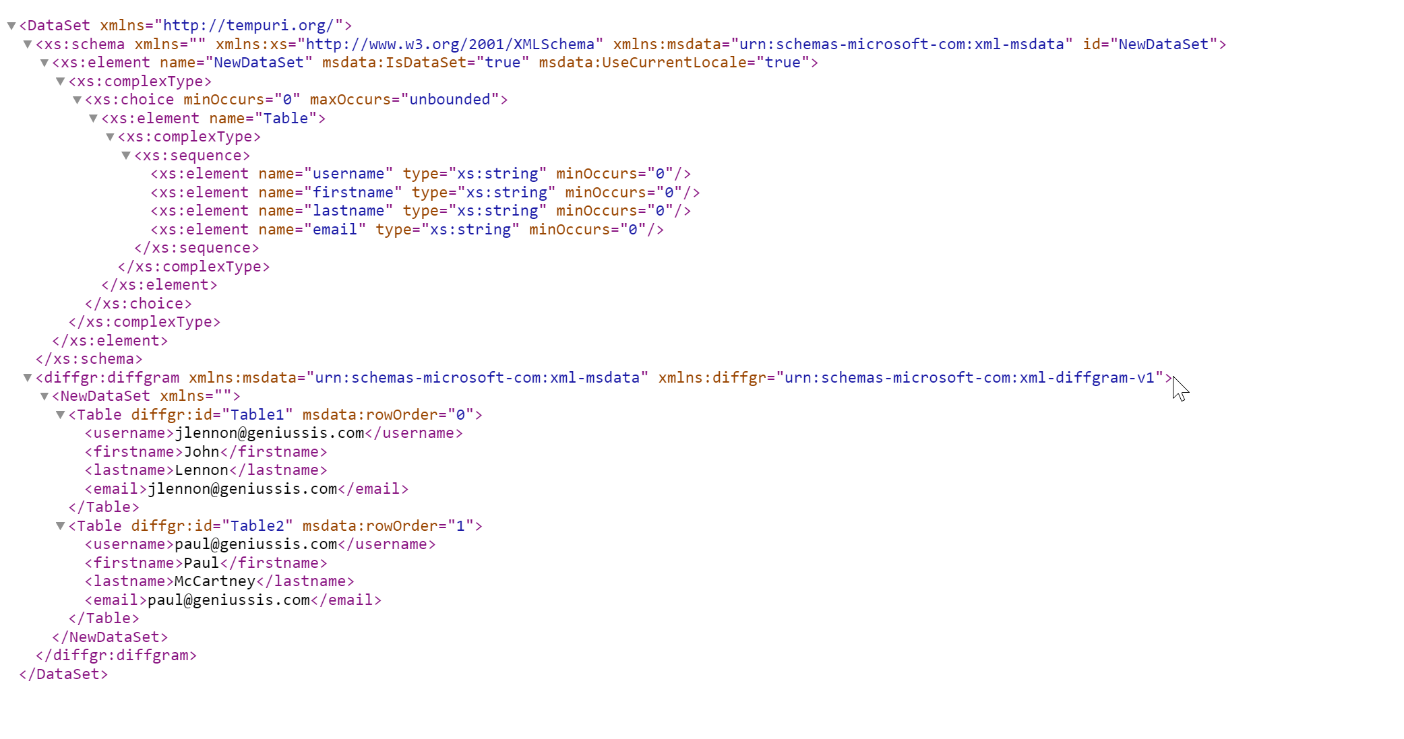

SaveCourse
This webservice will allow you to create a new course or update an existing one. If the provided CourseID is found in the database, that course will be updated, otherwise a new course will be created.

The CourseID should be the ID of the course template this course should be mapped to in Blackboard Learn.

The field “CourseName” is required but does not have to be unique.

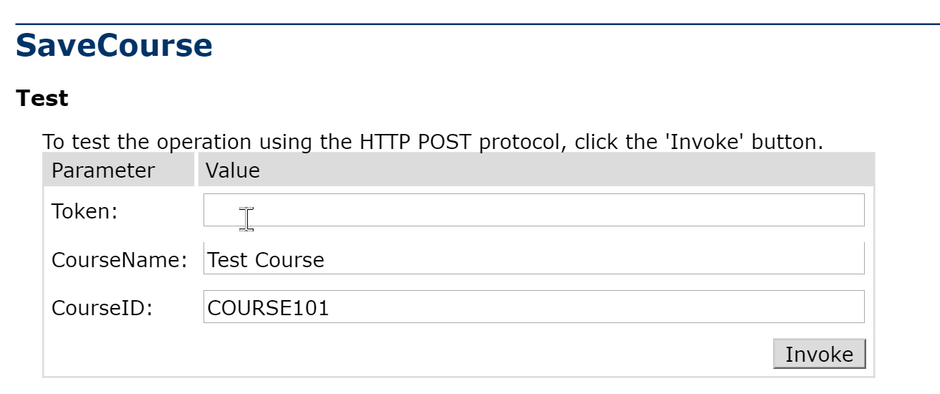

The webservice will return a message confirming the course was created (including the Genius-assigned ID), or an error message.

SaveSection
This webservice will allow you to create a new section or update an existing one. If the provided SectionExternalID is found in the database, that section will be updated, otherwise a new section will be created.

The SectionExternalID should be a unique ID that will be used in future calls to reference this section, such as when a registration is created. Therefore, it should be a unique ID that is tracked in a separate system. If no SectionExternalID is provided, Genius will automatically assign a unique number and provide that number in the call return.

The CourseID should be the ID of the course this section should be created under (i.e., the template to be used in Blackboard Learn).

The field “SectionName” is required but does not have to be unique.

If no Cap is specified, Genius will assume the section does not have a seat limit.

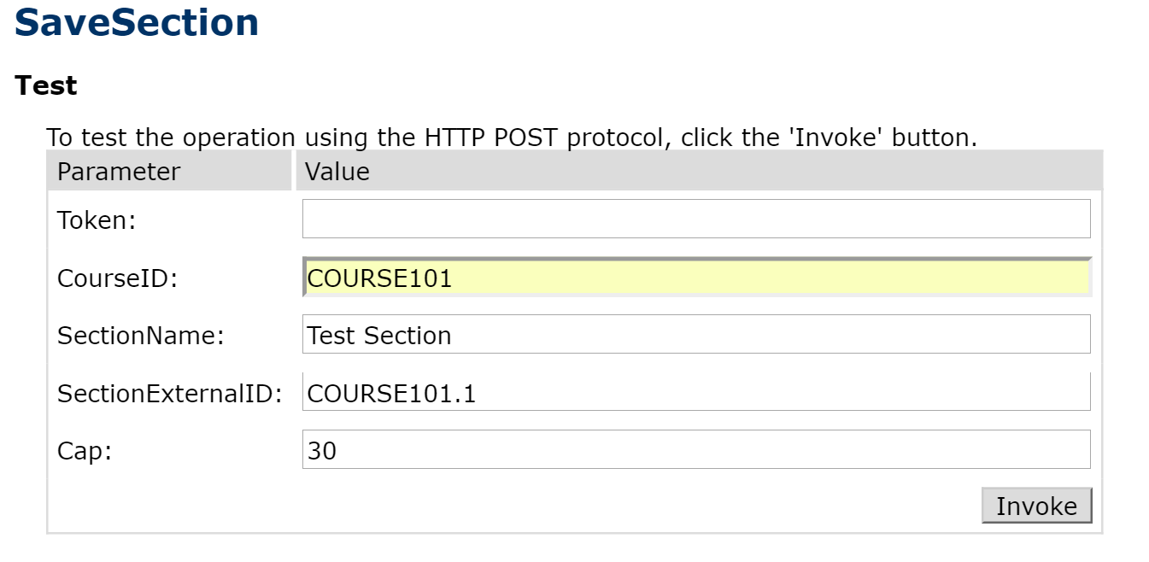

The webservice will return a message confirming the section was created (including the Genius-assigned ID), or an error message.

CreateRegistration
This webservice will allow you to create a new registration by enrolling an existing learner into an existing section. The learner is identified by his/her username, and the section is identified by its “SectionExternalID”.
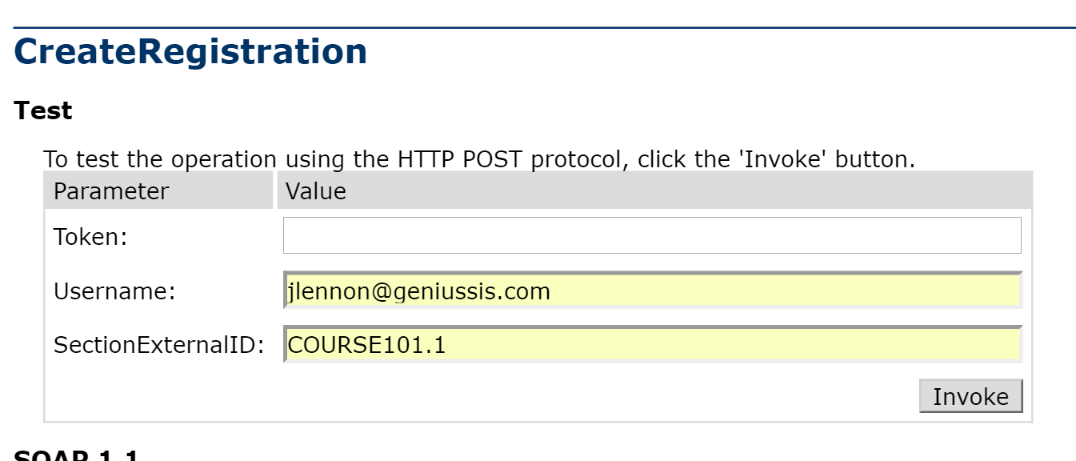

The webservice will return a message confirming the enrolment was created, or an error message.

DropRegistration
This webservice will allow you to drop an existing registration by specifying an existing learner and existing section combination. The learner is identified by his/her username, and the section is identified by its “SectionExternalID”.
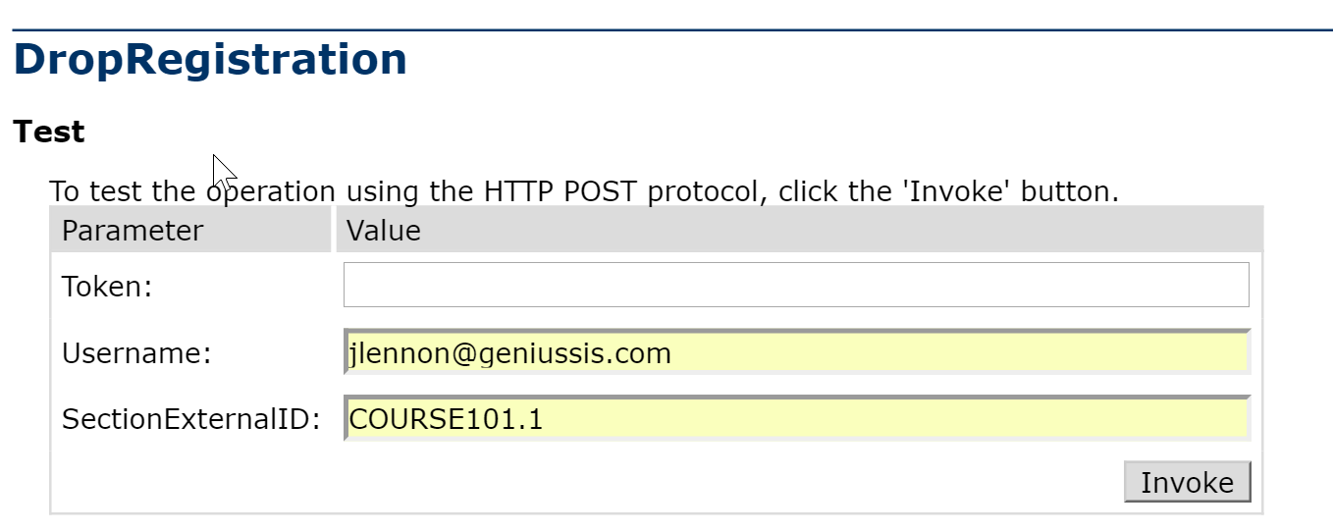

The webservice will return a message confirming the enrolment was dropped, or an error message.

CompleteRegistration
This webservice will allow you to complete an existing registration by specifying an existing learner and existing section combination. The learner is identified by his/her username, and the section is identified by its “SectionExternalID”.
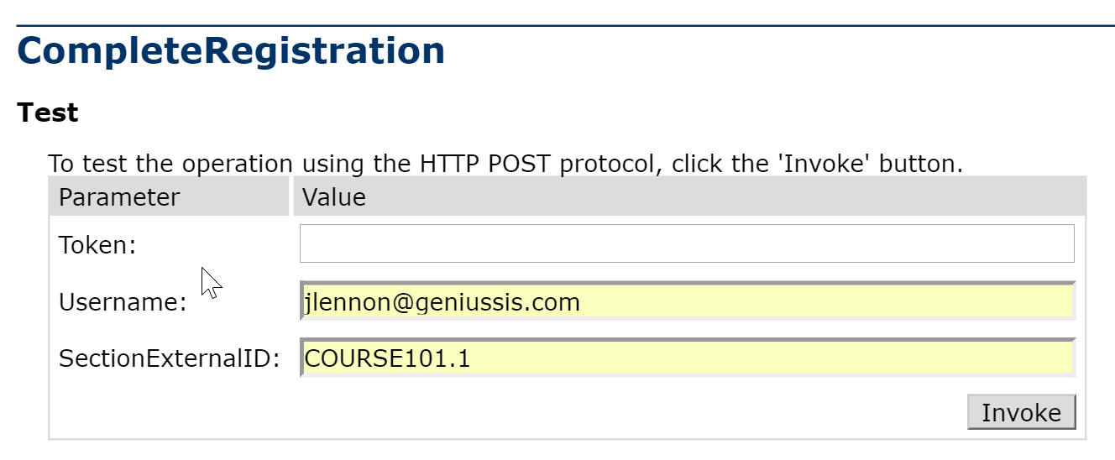

The webservice will return a message confirming the enrolment was completed, or an error message.

TransferRegistration
This webservice will allow you to transfer an existing registration from one section to another.

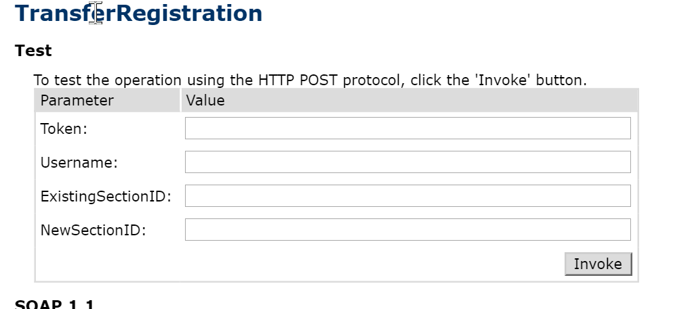

The webservice will return a message confirming the enrolments was transferred, or an error message.

AssociateLearnerToCoach
This webservice will allow you to associate an existing learner to an existing coach.

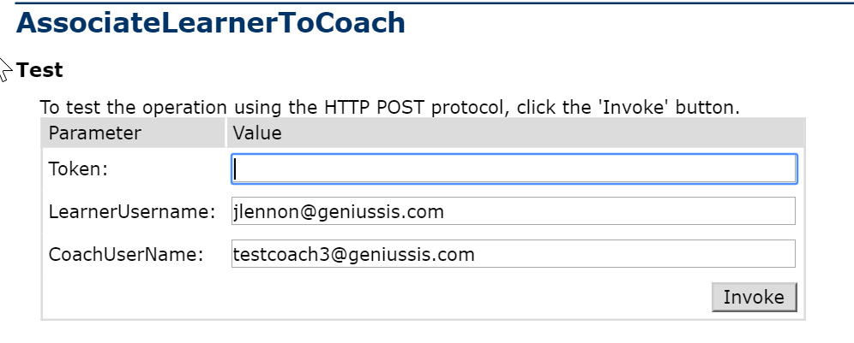

The webservice will return a message confirming the association was created, or an error message.

RemoveLearnerFromCoach
This webservice will allow you to remove an existing association between a learner and a coach.

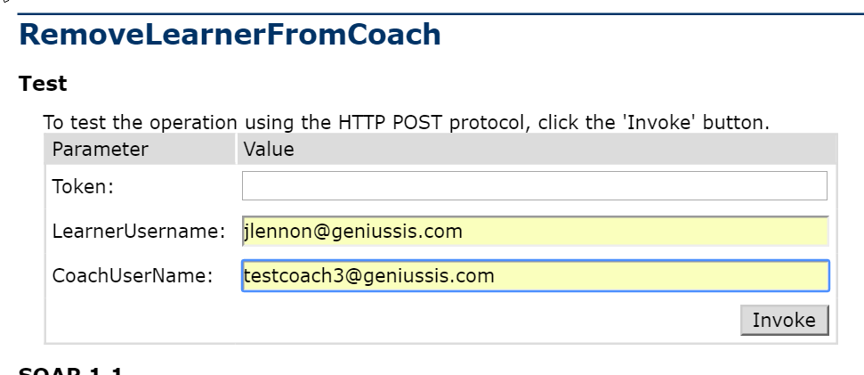

The webservice will return a message confirming the association was removed, or an error message.

GetCourseInformation
This webservice will return a list of all existing sections, usually when an external catalog is used.
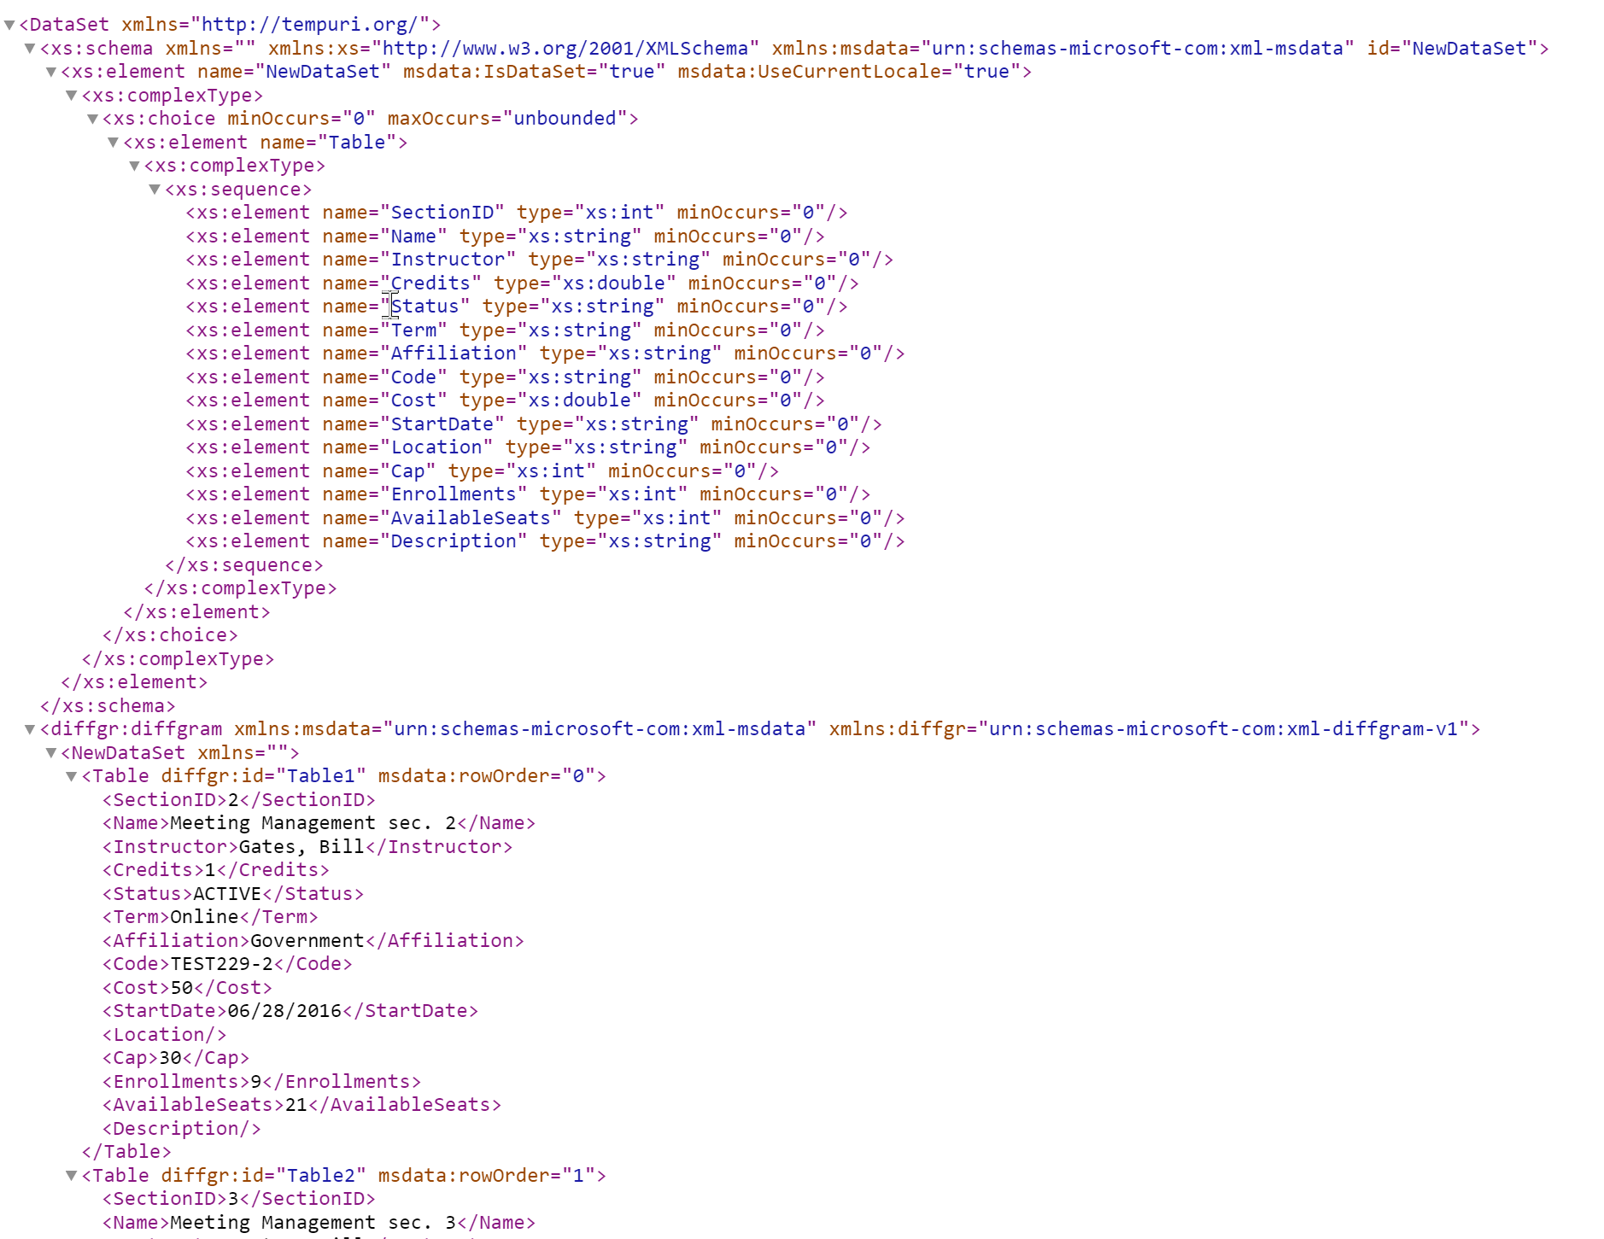

RunQuery
This webservice allows you to run a generic query against the database. Only read-only queries are allowed. The parameter “Query” should have the SQL statement

This webservice should be used carefully as it may have a performance impact.

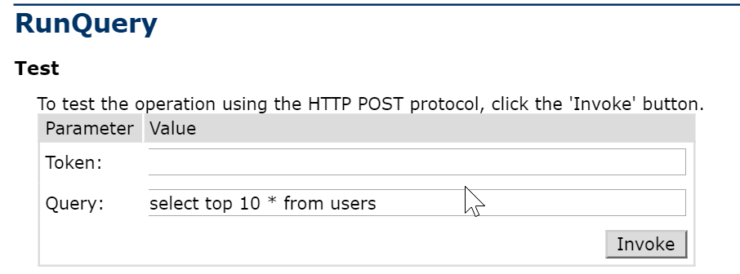

The webservice will return a message confirming the enrolments was transferred, or an error message.

Validation
Once the API calls are completed, the resulting scenario can be validated by logging in as an administrator to the Genius UI and then performing the following steps:

- Click on the “Affiliations” tab to confirm the affiliation exists

- Click on a particular affiliation to confirm the Managers are created

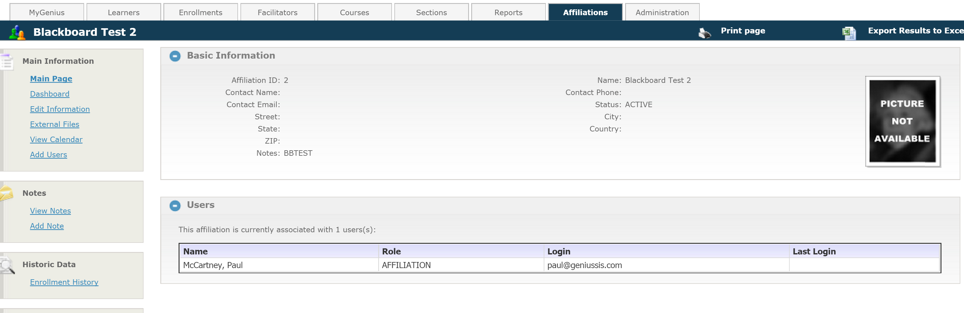

- Click on the Learners tab to confirm they are created, and mapped to the correct affiliation

- Click on the Courses tab to confirm the courses were created

- Click on the Sections tab to confirm the sections were created

- Click on a particular learner to confirm he/she is enrolled in the requested sections

